**AWS Aurora Databases**

* Aurora is an Amazon RDS family database i.e. compatible with Postgres and mysql.
* This is a fully managed database and it provides 5 times better performance than mysql and 3 times more performance than Postgres without doing any programatic changes in your application.
* RDS Multi-AZ Architecture:  
  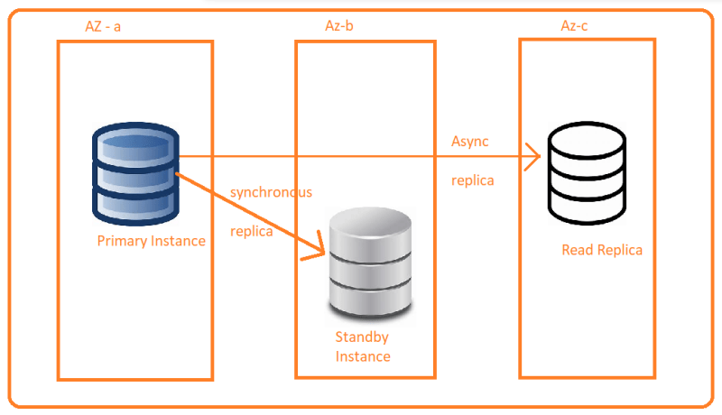
* Aurora Architecture  
  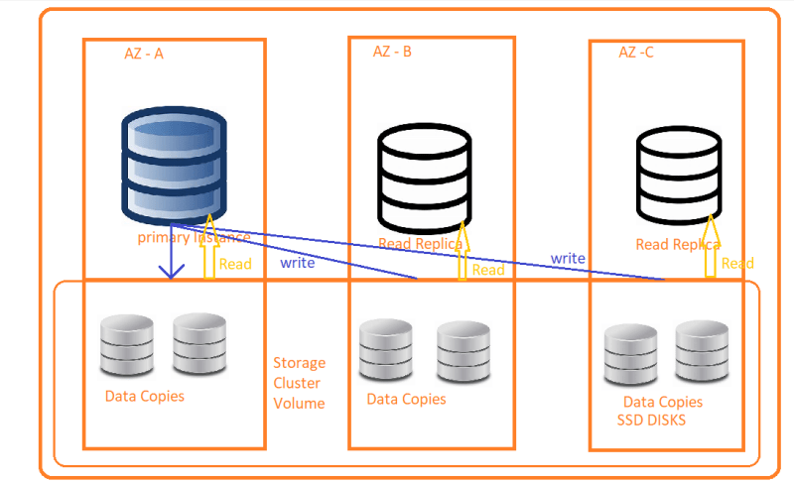
* Aurora Global Database: The same architecture as above plus two read replicas in different region.
* Aurora Serverless
* Lets create an aurora db  
  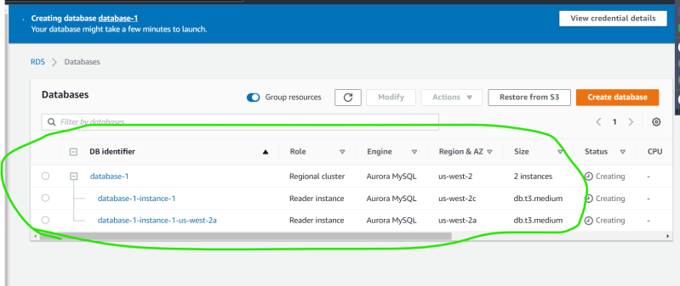  
  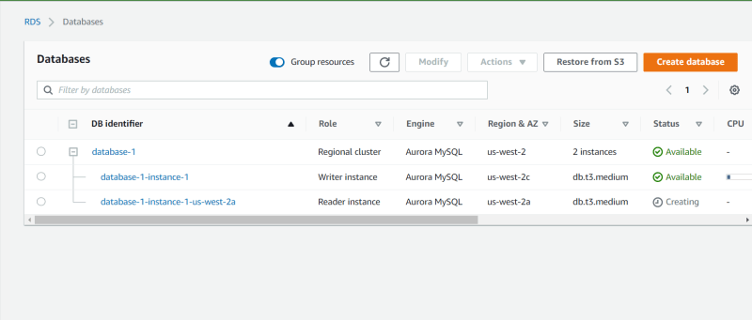  
  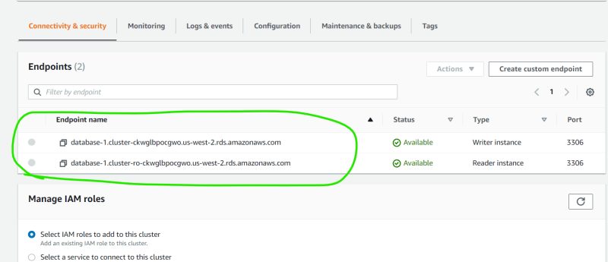  
  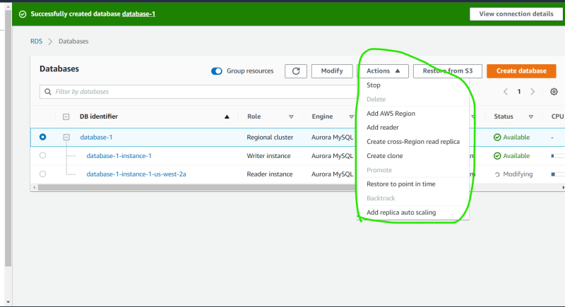
* Exercise: Create a pricing estimate for multiaz sql server with memory optimized and same size for aurora and compare the differences in costs.